**Prostate Cancer Dataset**

The problem consists of finding meaningful biomarkers in prostate cancer. This can be done via classification and feature selection for selecting genes that contribute to one or more different classifications. A dataset of 494 samples downloaded from the Genomic Data Commons (formerly cBioPortal) contains gene expressions for a few dozen thousand genes. You are free to work on one or more problems as discussed in class: classification, solving the multi-class problem, feature selection, other aspects, or a combination of these, by using one or more clinical variables (e.g., clinical stage of progression, primary site, Gleason score, etc.).

prad_tcga_clinical_data.xlsx contains the clinical variables for all 499 samples (patients) in the dataset.

prad_tcga_genes.xlsx contains gene expression ratios for a few dozen thousand genes. 494 samples

work on gene

feature selections(1 at a time)(once, we may do more later)

chi square - fast

~~MRMR – too long~~

F test

Mutual information

Plot graph( a range that will be defined when we run the ML algorithm, use SVM with fix param)

Plot different graphs using different SVM param (kernel, C, gamma)

classifications

SVM

Diff kernels in svm

Param tuning using grid search

Select a relatively small number of features using feature selection method that work best for us, and then perform grid search in different SVM params.

We will then take the best feature selection method and also the best parameter from the parameter tuning and classify the data using SVM.

classes: in clinical data excel file/ GLEASON_SCORE, CLIN_T_STAGE, PATH_T_STAGE

first focus on **Gleason score**

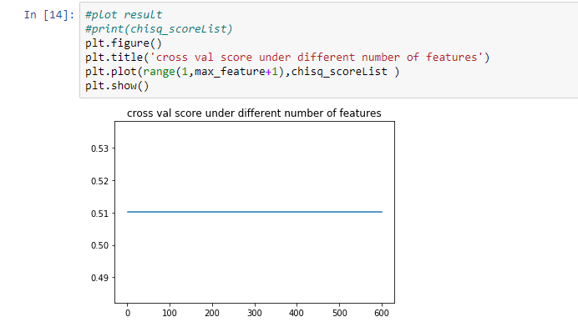

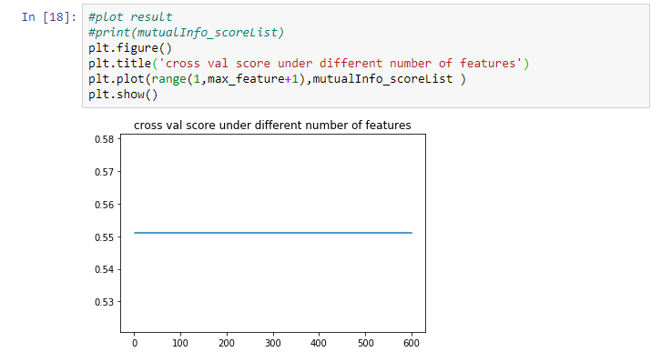

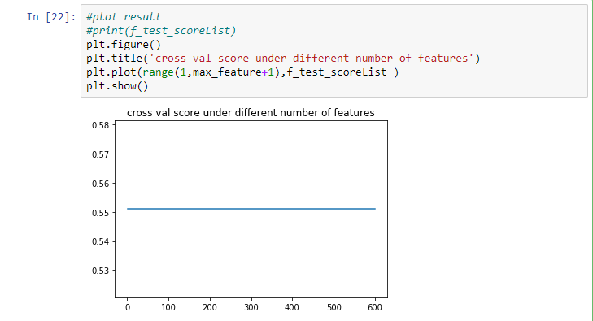

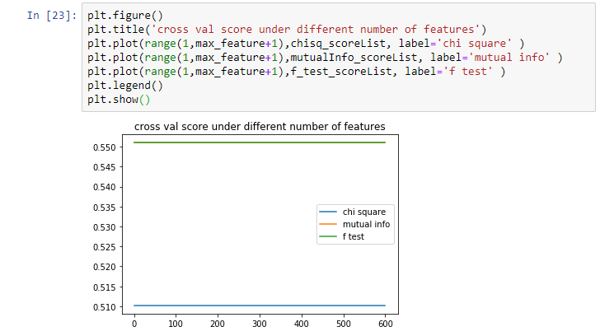

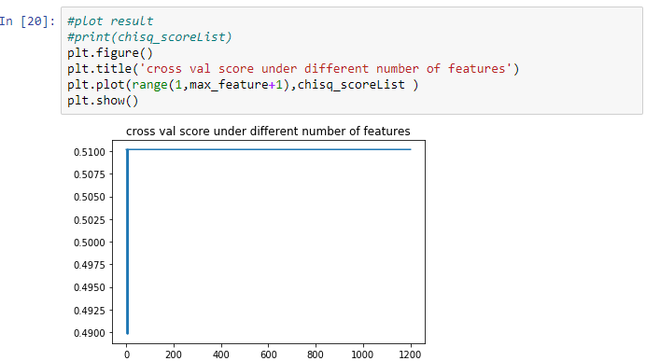

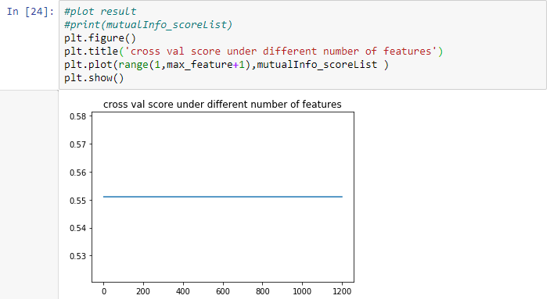

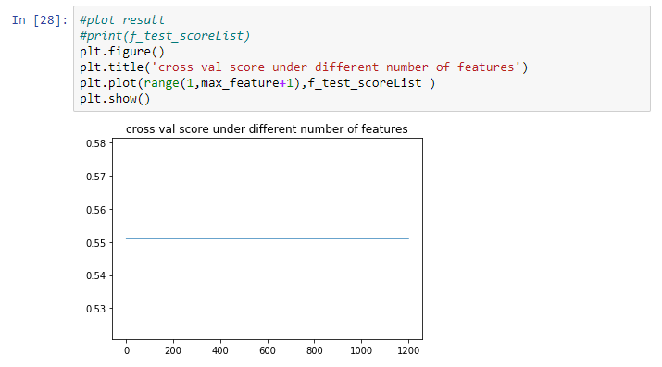

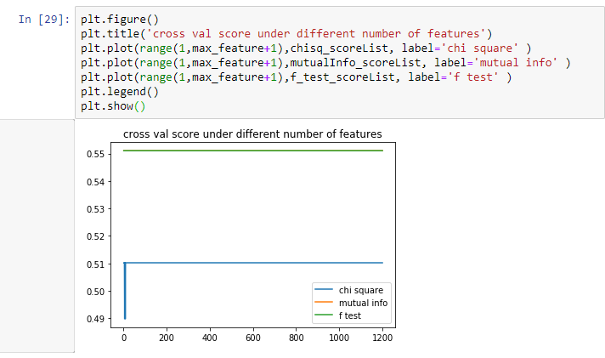

More details of the clinical variables and the gene expression tables can be found at <http://www.cbioportal.org/data_sets.jsp> . Once there, search for “prostate adenocarcinoma” and choose “Prostate Adenocarcinoma (TCGA, Provisional)” that contains 499 samples.